Vehicle Dynamics Simulation

Entry Programming Assignment

Answering the Theoretical Questions Part

By Oz Elbaz

1. Steady State Effect of Bias in Mechanical Road Wheel Servo for Pure–Pursuit Tracking

A bias in the mechanical road wheel servo, when applying the Pure-Pursuit tracking algorithm, would result in constant offset on the steering angle. This would cause the vehicle to deviate from the desired path, typically resulting in a curved path instead of a straight one when the vehicle is supposed to go straight.

1. This kind of effect can be seen in the simulation below, where the **biased vehicle’s steering servo** has an angle based of 1.0 degree:

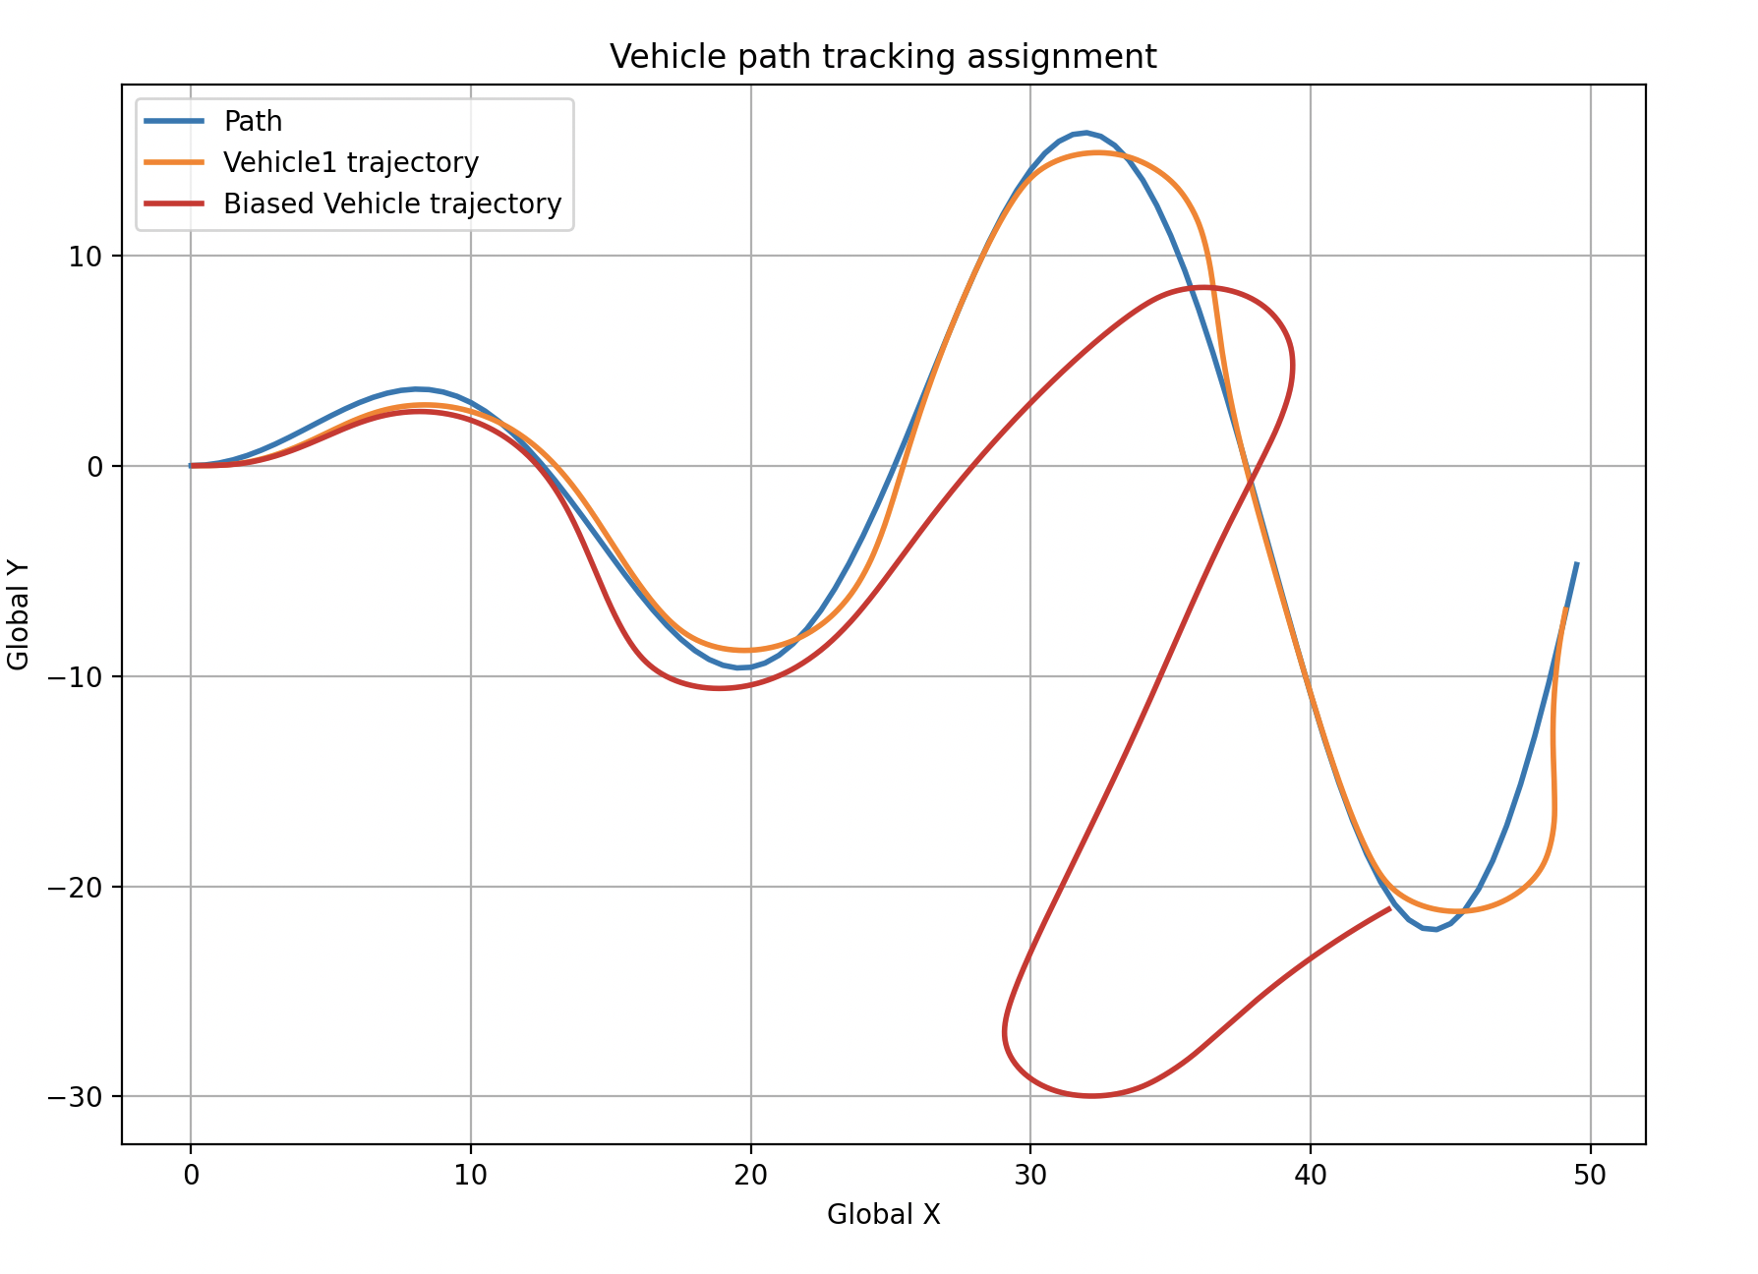

1. Write an expression
2. Model for Higher Speeds: Dynamic Bicycle Model

For higher speeds, the kinematic bicycle model becomes less accurate because it neglects important dynamic effects. A more accurate model for higher speeds is the dynamic bicycle model, which includes the following considerations:

* Lateral Tire Forces: The lateral forces generated by the tires, which depend on the slip angles and tire characteristics. In the kinematic model, the tires are assumed to have no lateral slip, meaning the direction the tires are pointed is the direction the vehicle will move.
* Inertial Effects: The mass and moment of inertia of the vehicle, which affect the lateral dynamics. So far, we assumed that there are no lateral forces and therefore no lateral acceleration. Because of that, we haven’t had use for the mass and moment of inertia of the vehicle.
* Longitudinal Dynamics: Besides lateral forces, the tire experience forces also on the longitudinal axis due to friction and tire coefficient.
* Load Transfer: In the bicycle dynamic model, the center of mass doesn’t have to be at the center of the vehicle. This affects on the load transfer in the tire forces, which becomes significant at high speeds and during cornering.